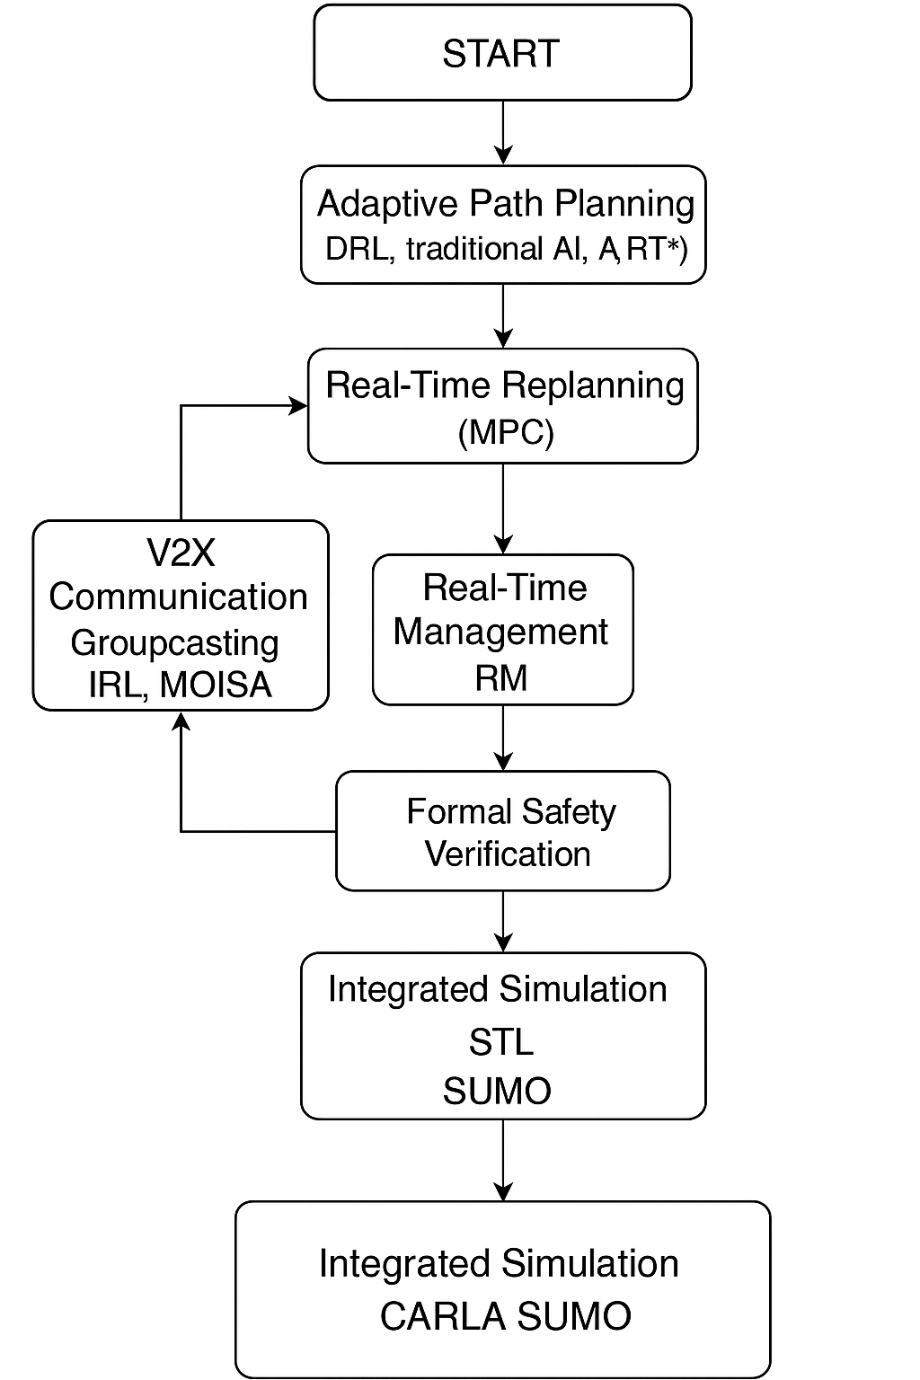**Flow Chart Explanation**

**🔹 START**

This represents the beginning of the autonomous vehicle system execution — initializing all modules such as sensors, communication protocols, environment simulators (CARLA, SUMO), and loading initial configurations (map, vehicle positions, etc.).

**📦 *Adaptive Path Planning (DRL, traditional AI, A, RRT*)\*\***

This module is responsible for generating the initial route:

* **DRL (Deep Reinforcement Learning)**: Learns optimal behavior through trial and error (e.g., PPO, SAC).
* *A / RRT*\*\*: Classical deterministic path planning algorithms for baseline navigation.
* **Goal**: Create a globally feasible path from the vehicle’s current location to its destination, considering static elements in the environment.

**📦 Real-Time Replanning (MPC)**

This box handles **on-the-fly path adjustments** using:

* **Model Predictive Control (MPC)**: Continuously updates the vehicle’s local trajectory in real time by predicting future states and adjusting control inputs.
* Reacts to dynamic changes like moving obstacles, new goals, or traffic updates.

**📦 V2X Communication (Groupcasting IRL, MOISA)**

This module facilitates communication between vehicles and infrastructure:

* **Groupcasting**: Sends messages to nearby vehicles within a certain radius.
* **IRL (Incremental Redundancy Hybrid ARQ)**: Enhances reliability of message delivery.
* **MOISA**: Used if the communication involves sensor data from a WSN to determine the optimal cluster or message routing strategy.
* **Purpose**: Share obstacle detection, braking, or route update information to ensure coordinated behavior.

**📦 Comfort and Safety Control (FVD) Fedb. Loops**

Focuses on **passenger comfort and vehicle stability**:

* **FVD (Full Velocity Difference Model)**: Minimizes sudden acceleration/deceleration by taking into account velocity differences between vehicles.
* **Feedback Loops**: Continuously monitors and adjusts vehicle behavior to maintain ride comfort and avoid jerky movements.

**📦 Real-Time Management (RM)**

Acts as the **central coordinator**:

* Gathers input from planning, V2X, and comfort modules.
* Makes runtime decisions (e.g., switch lane, slow down, stop).
* Ensures coherence across the entire system and resolves conflicts (e.g., path vs. comfort vs. communication).

**📦 Formal Safety Verification (STL)**

This module enforces safety rules using:

* **STL (Signal Temporal Logic)**: A mathematical language used to define safety constraints over time (e.g., “never collide,” “maintain distance ≥ X for T seconds”).
* Continuously checks if the vehicle behavior violates any of the formalized rules and triggers re-planning or safe-state fallback if needed.

**📦 Integrated Simulation CARLA SUMO**

This is the final layer that **executes and tests the full system** in:

* **CARLA**: High-fidelity vehicle simulation (urban layouts, sensors, pedestrians, physics).
* **SUMO**: Traffic flow simulation (routing, traffic lights, V2X interactions).
* Offers real-time feedback and performance metrics.